TARGET BOL

- 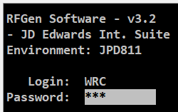
  - ID: WRC
  - Password: 000
- 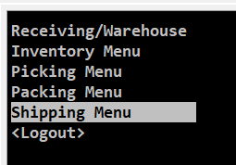
- Master BOL
  - 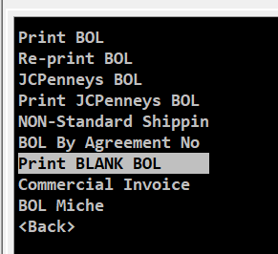
  - 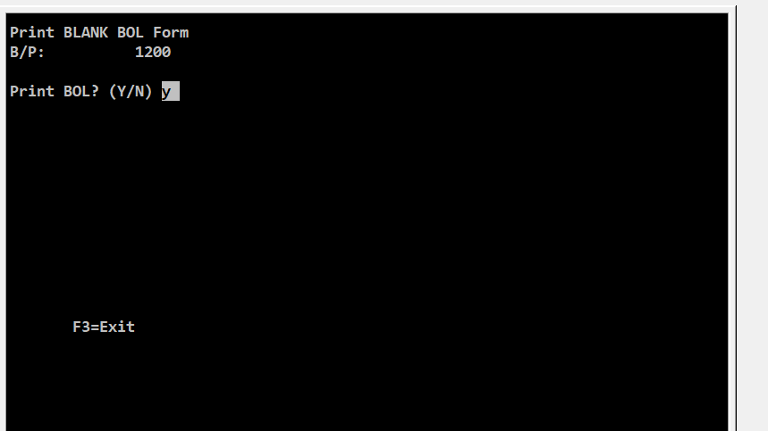
- 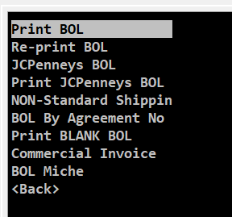
- 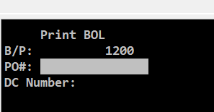
- 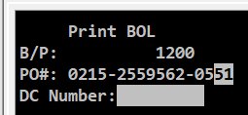
- 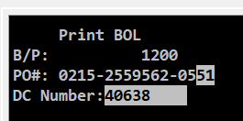- Deliver To Number
- 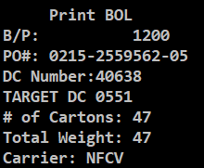
- 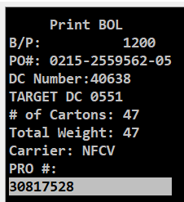
- Freight Terms 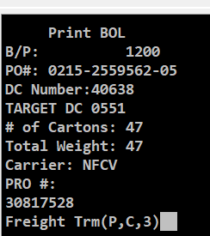
  - Prepaid - Never
  - Collect - NFI
  - 3-rd party – TL/Direct to Target DC
- 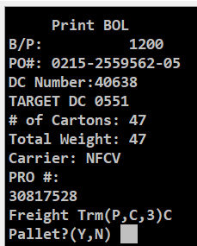
  - Y if DC is palletized by itself
    - 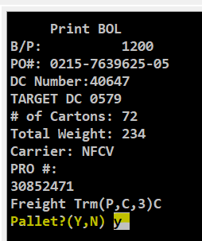
      - 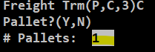 enter how many pallets
  - N if Pallet contains other DC’s and is separated by Slips
- 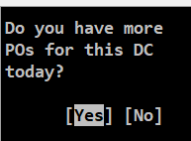
  - If you have another PO for this DC then click yes
    - If Yes – enter PO information
      - 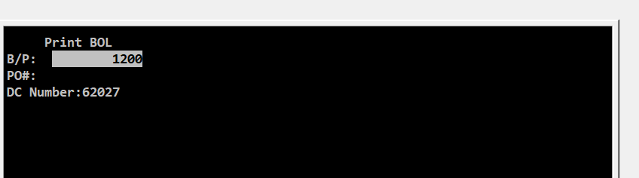
  - If not then no
- 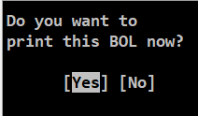
- Reprint
  - 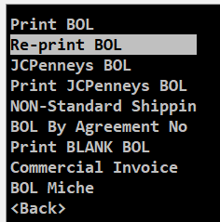
  - 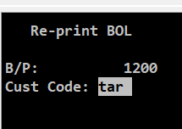
  - 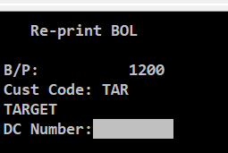
  - 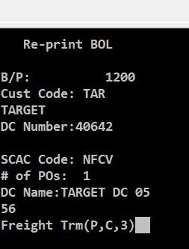

Master BOL Form
- Go J:\Roman Sunstone Warehouse\BOL open the template named: Master BOL Target NFI
- 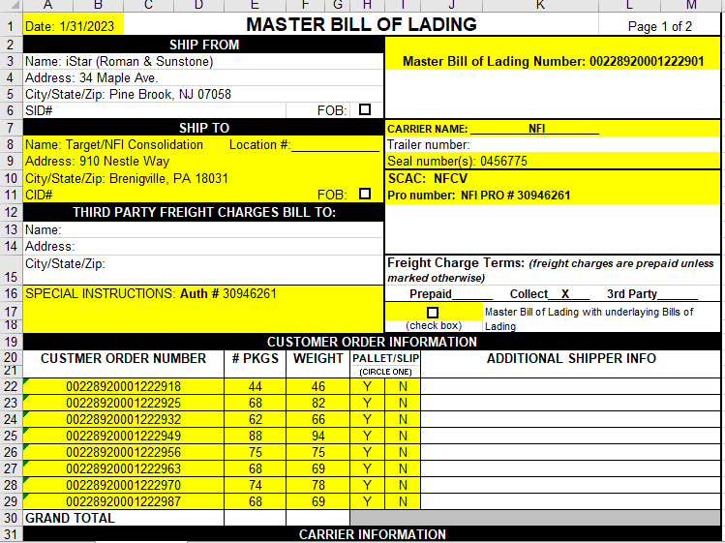
BOL# Example:
40200228920001222901
40200228920001222901

  - Fill out all highlighted spaces
  - BOL# - use scanner to scan individual BOL for each DC & Blank BOL page
    - Make sure to delete the 402 in the front of the sequence

